2022
Italian Heritage Society Scholarship Awards
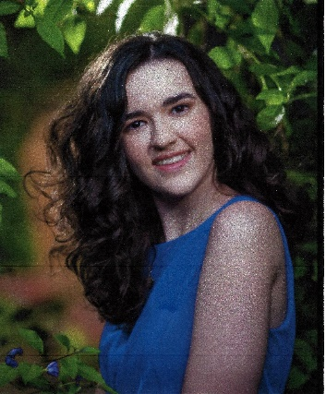
Kathrine Hodges $1,000 | Gianna Francesca Campo $1,000 | John Campo $1,000 | Gianna  Marie  Grammatico  $1,000
Adam Henry Bucholtz $500 | Joseph Stanley Bucholtz  $500 | Katherine Compagno $500 | Isabella G. Cardinale $500

