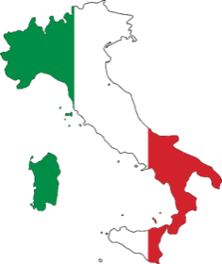
Italian Heritage Society
OF THE MONTEREY PENINSULA

Book Submission Guidelines

Thank you for your interest in submitting your own or your family member’s story to be included in our next book: Italian Americans: “We Don't Just Fish!” Please review the guidelines below to make sure you have included all the information needed:

- Each story should have a minimum of 500 words--maximum 2,500 words (2 to 10 pages) and include two or more photos as jpegs with captions; indicate photo placement in the story. Please ensure you have rights to all photos submitted.
- Send story as a word document printed in Times New Roman font size 14

- INCLUDE at the top of all stories:
  - Full name of person (first, middle, last)
  - Year of birth & Year of passing, if deceased
  - Occupation / Occupations
INCLUDE in the stories:
  - Where was the person or you born?
  - Where did they/you grow up?

- SUGGESTIONS for writing a story:
  - How did their/your Italian upbringing affect who they/you became
  - What community contributions have they/you made?
  - Who influenced them/you the most in their/your life?

- When submitting your story, please include:
  - Author’s name and contact information--phone & email

PLEASE SUBMIT STORIES BY NOVEMBER 1, 2021

When you're ready to submit your story, EMAIL it as a word doc with photo attachments to: italianheritagesocietymonterey@gmail.com
Annamarie (831) 375-1598 Judy (831) 375-7067

Please also submit fishing stories that did not make it into our book ITALIAN FISHING FAMILIES OF MONTEREY.
Help us spread the word!
Check out our website: www.italianheritagemonterey.org

We are an IRS-approved 501(c)3 Non-Profit organization (Federal Tax ID #51-0159447)

